МИНИСТЕРСТВО НАУКИ И ВЫСШЕГО ОБРАЗОВАНИЯ РОССИЙСКОЙ ФЕДЕРАЦИИ

Санкт-Петербургский национальный исследовательский университет информационных технологий, механики и оптики

Мегафакультет трансляционных информационных технологий

Факультет информационных технологий и программирования

**Лабораторная работа №2**

**По дисциплине «Web-программирование»**

**Шаблонизация веб-страниц приложения**

**Выполнили студент группы М33081**

**Аль Даббагх Харит Хуссейн**

**Проверил**

**Приискалов Роман Андреевич**

САНКТ-ПЕТЕРБУРГ

2022

Содержание

HBS and Partials 2

hbs installation 2

Partials 2

# HBS and Partials

## hbs installation

hbs installation and registration was discussed in the previous lab.

## Partials

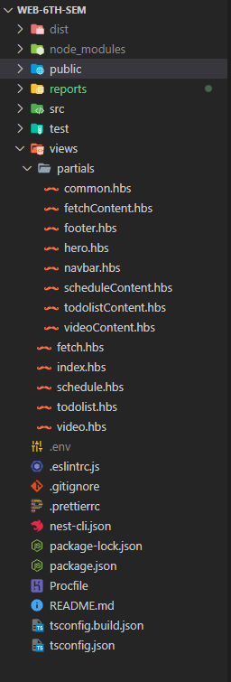In handlebars, template reuse is done using partials. Partials maybe called directly from other partials. They can be separated in .hbs files.

During the lab work we had to separated our reusable components (From our static resources from the previous semester) into partials as shown in the image to the right.

To call a reusable partial inside a template. We use {{> partial_name}}.

To let the different pages work, we need to add these routes in the controllers.

Example in the image below.

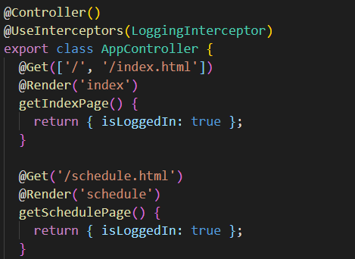

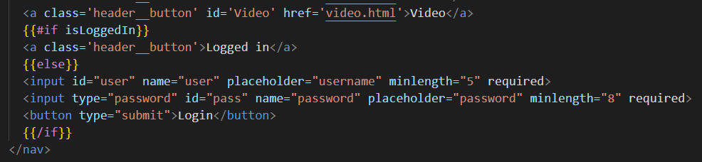Next we were required to add two states:

Handlebars is not a logical language, but it has some basic logical operators (helpers) as shown in the previous image.

After that we were required to update the footer with the time required for the server to process the request. To do that we need to implement interceptors, which will intercept the response, add a header with the processing time, and update the HTML document before sending it to the client.

To quickly generate a new interceptor in nest, we can use its CLI:

nest g in logging

The g stands for “generate”, in stands for “interceptor” and logging is the name of the interceptor.

The following image shows the implementation for the interceptor:

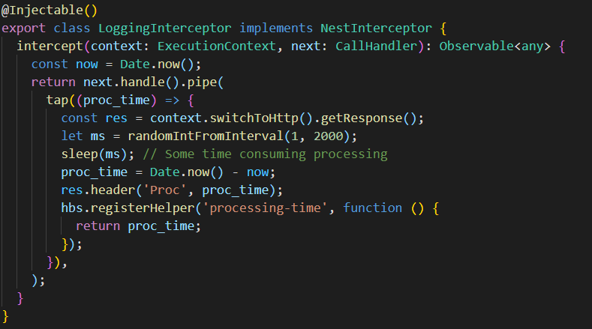

In this method, a header is added to the response, plus hbs will register a new custom helper called ‘processing-time’ which will contain the processing time on the server side, which can then be injected in the footer of the page like so:



Keep in mind that the first <p> tag will be filled using a custom JS script from the previous semester.